**Getweather.org**

**Site Name**

The site will be known as **getweather.org**. It will contain updated information on weather conditions surrounding various parts of Southeastern Idaho. This domain would cost about $12 per year.

**Site Purpose**

The website will provide updated weather information and forecasts such as temperature, current condition (rain, cloudy, etc.) wind chill, wind speed, around Southeastern Idaho. It will also contain traffic conditions, driving suggestions, road closures, construction zones, accident information and school closures. When it rains or snows, there will also be information regarding the amount of each at various locations and elevations.

**Target Audience**

* **Who –** Residents of the Southeastern Idaho and surrounding area.
* **Age –** Anyone 12 years or older could be interested in content and should be able to easily navigate the site.
* **Motivation** – To become up to date on current weather conditions and potential hazards as they prepare for appropriate attire, activities, and travel each day.

**Personas**

**Jeff Whalen**

* **Demographics and Education** – 52 years old. Commercial potato farmer over 100 acres of land. Has an Associate’s Degree in Agricultural Business from Ricks College.
* **Motivation for using site** – Stay informed on extreme or hazardous weather conditions so he can quickly make and execute any necessary plans to protect and continue potato production and distribution.

**Abby Shaffer**

* **Demographics and Education** – 18 years old. Currently a high school senior at Preston High School.
* **Motivation for using site** – Keep informed on driving conditions or potential school closures during the Winter months so she can make it safely to and from school and other activities.

**Scenarios**

* When is it supposed to start raining today?
* After seeing a road closure, what is an alternative route I could take to get to work?
* How bad is traffic on I-15 right now?
* How should I prepare for the upcoming snow storm?
* What does it look like near Fish Haven today? (updated pictures)

**Site Map**

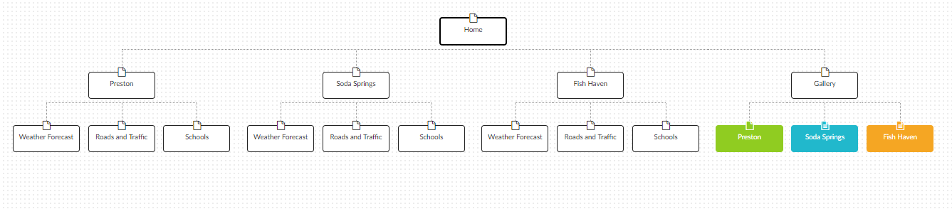This section describes the structure of the website:

*The site would only let me download a PDF file of the site map if I purchased premium, so I took a screenshot instead.*

**Color Scheme**

**Primary Colors (Nav/Content)**: #8ee3e6 #5F9EA0 #395c5e

**Secondary Colors (Header/Footer):** #DEB887 #b99a71 #66543d

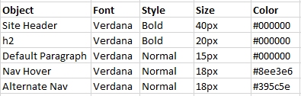**Typography**